
Primary 3/2 Newsletter, Term 3
Dear Parents and Carers,
Happy New Year! I hope you had a lovely and relaxing holiday. It has been great welcoming Primary 3/2 back to school and getting started on our new learning for term 3!
This is an exciting term with the celebrations of Scotland, World Book Day, Chinese New Year and Eid-Al-Fitr coming up. We have lots of learning taking place which I’d like to outline for you. This year, reports will be issued in the middle of March which will give you the opportunity to find out how your child is progressing at school.
Classroom Routine
Our classroom routine is changing this term. On Thursdays between break and lunch and on Friday mornings, I will not be in class. During this time, Mrs Saeed and Miss Murdoch will take the class. Miss Murdoch will be taking the children outside on a Friday so please ensure children are wrapped up warm for outdoor learning. They will be teaching talking and listening skills, science and some aspects of maths.
Gym Days
Our PE days will be on Mondays (indoor) and Tuesdays (outdoor). Please send your child ready for gym on these days. Dark coloured shorts/ leggings/ joggers, trainers, white polo shirt, and school jumper/ cardigan. No earrings please. It would be helpful to keep a pair of indoor shoes in school for use in the gym hall. These can be clean trainers or sandshoes.
Literacy
For literacy this term we will continue to follow our Jolly Phonics programme and weekly jolly reader reading books. There are questions at the back of the book which you can use to discuss the text with your child. Please ensure that reading books are in school bags every day as we use them in school. If you have any books at home that haven’t found their way back to school yet, please return these as other classes access these books too.
Children will continue to practise their new sounds and key words which are issued on seesaw each Monday. Over the next couple of weeks, we will be exploring poetry and Scots language. In February, we will be moving on to writing instructions and explanations. We also will be looking at non-fiction texts. Please continue to read with children at home to support their learning.
Maths
In Maths, we will continue our work on addition and subtraction skills as well as comparing numbers and rounding to the nearest 10. We will also be finding doubles and learning to multiply by 2 and 4.
In Beyond Number, we will be exploring symmetry, time to the hour and half past and we will also be exploring the different ways in which we can present data. Please encourage children to look for symmetrical patterns when out and about and look at the time during your daily routines- What time do you get up in the morning? When do we have dinner? What time do we have to be at school for?

Context of learning
For our first context of learning this term we will be learning all about the season of Spring linking in with the festival of Holi! We will compare different religious festivals, perform dance routines inspired by the festive dances and explore life cycles through science. We will also be observing and recording the Spring weather and growing our very own butterflies!
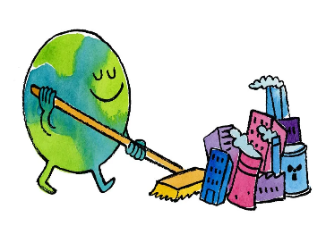
In the second half of the term, we will be exploring how we can change the world linking in with Earth Day which will be the focus of our class assembly in April. We will be learning about different materials and how we can recycle them and we will also create art and poems to share messages about how we can help the world. During this topic we will identify local issues and take part in a local litter pick, why not have a discussion your child about one of the ways you can help the world at home? (Turning off the lights when you leave a room, turning off the tap when brushing your teeth, building a bug hotel in the garden.)
Health and Wellbeing
In HWB this term, we will continue to focus on keeping our bodies healthy and looking at our emotions which will give children the opportunity to think about and express their feelings. Internet Safety Day is on the 10th of February; we will be discussing the dangers of being online and when you should go to an adult for help. Please remind your child of the ages that they should have access to certain games/apps. We will also be revisiting the RSHP (Relationships, Sexual Health and Parenthood) programme. We will learn about friendships, people who help us, looking after plants and animals, our bodies and privacy.
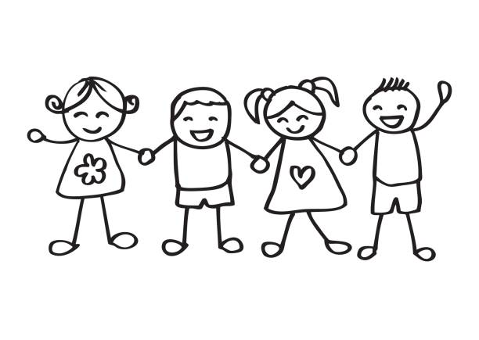

Other areas
We are extremely fortunate to have music instructors coming into the school again this term under the Baby Strings programme. Primary 3/2 will be continuing to learn how to play violins, violas and cellos.

Homework
All homework will continue to be issued on Seesaw, the weekly format (subject to change) is:
Monday | Spelling
Tuesday | Reading books/activity
Wednesday | Maths
Thursday | Other curricular area
Friday | No homework- feel free to practice anything your child may be struggling with!

Other homework will be issued throughout the year from other teachers in the school such as the monthly maths challenge, word aware or outdoor learning activities.
How can I help my child?
- Talk to your child about their new words for the week and try to use the words as much as possible. These will be posted on Seesaw each week.
- Practise reading books and tricky words daily.
- Encourage reading/sounding out words when out and about e.g., bus stops, shop names, menus.
- Complete weekly Sumdog challenges to earn coins!
- Select your child’s lunch option each day. This saves us lots of valuable learning time in class.
This term, homework and communication will continue on Seesaw. Please let us know if you have any problems accessing these or if you require a new family invite/home learning code for your child. We will be posting learning logs and other pictures of children’s work and activities each week for families to view at home. Thank you for your continued help and support to Blackfriars Primary!
Miss Cox,
Class Teacher

